Problem 1:

1+2+3+…+N

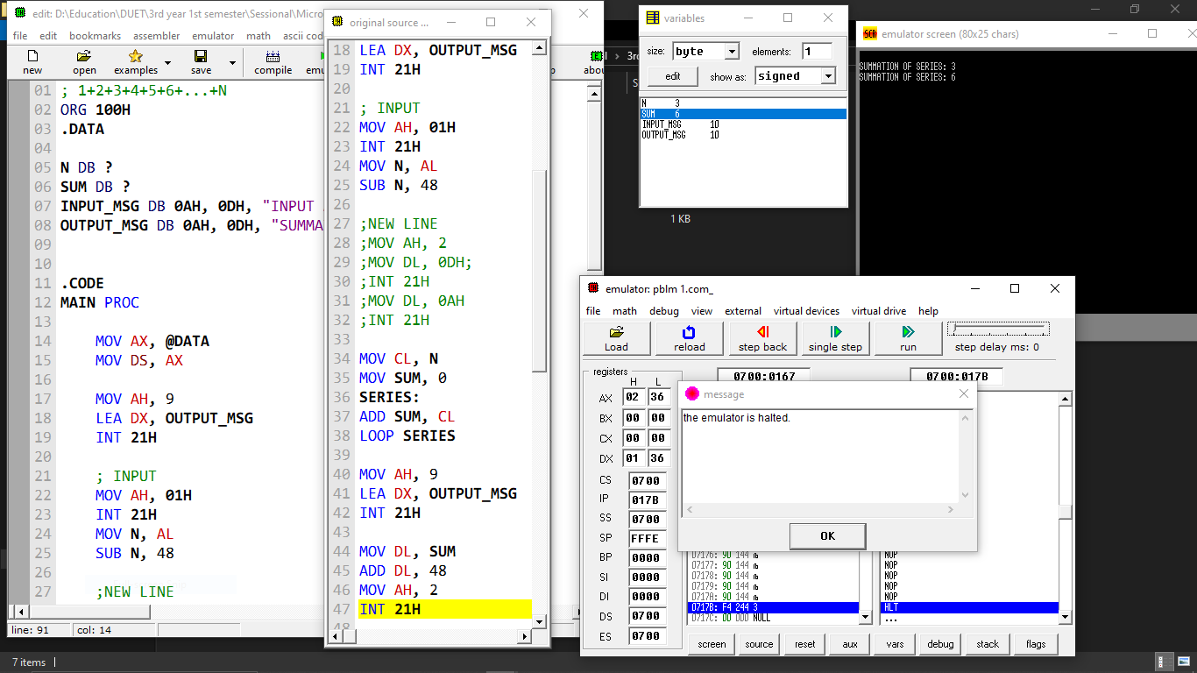

Problem 2:

12+22+32+…+N2

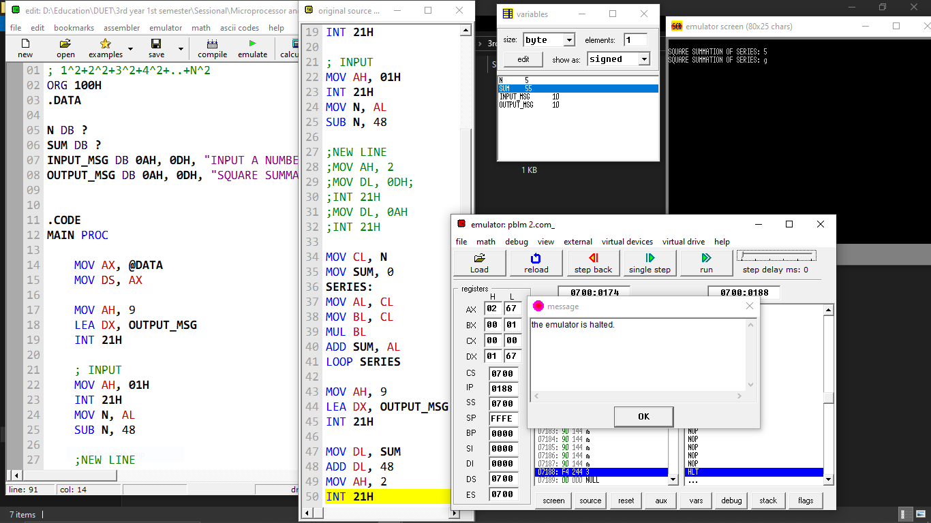

Problem 3: Corner handling

Input : Z

Output: abcde

yxwvu

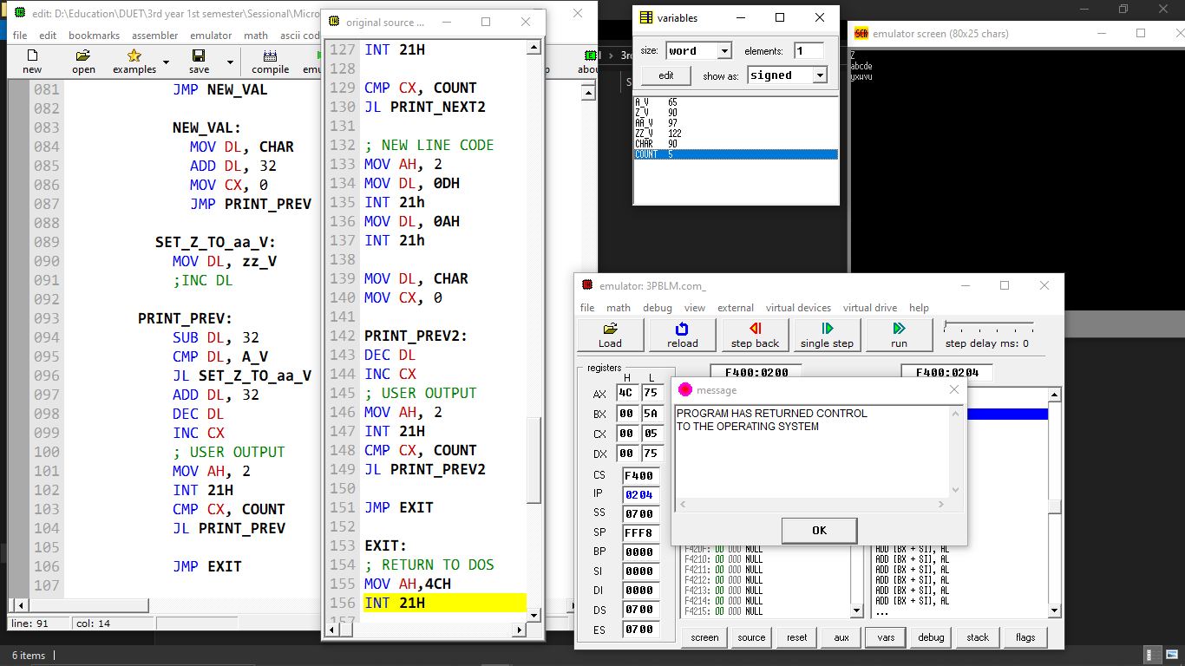

Problem 4: 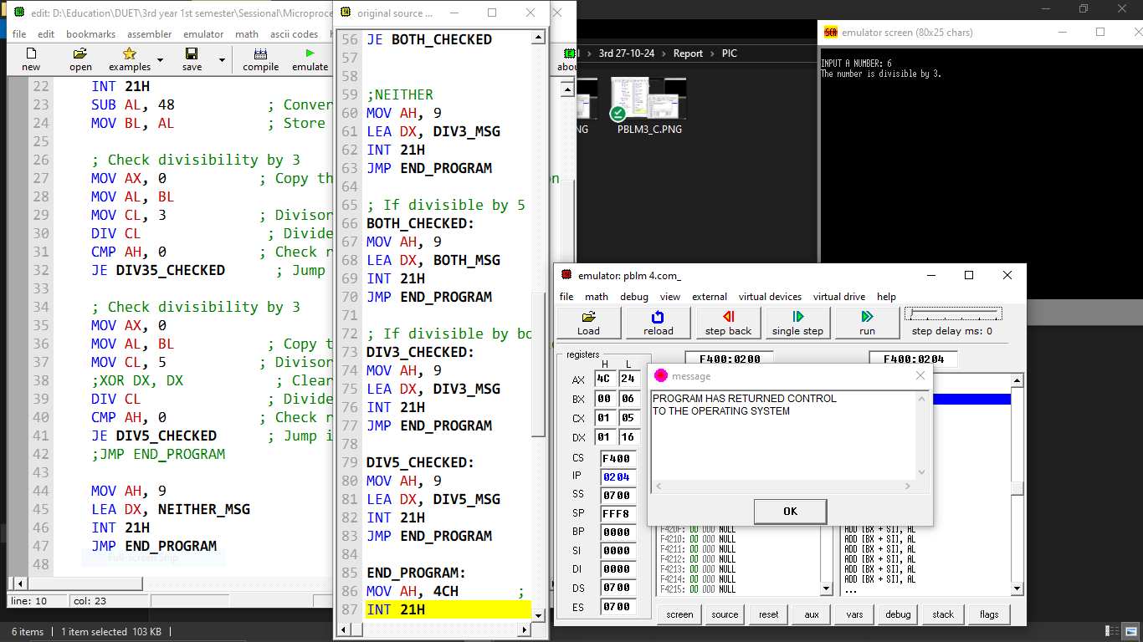

Problem 1:

1+2+3+…+N

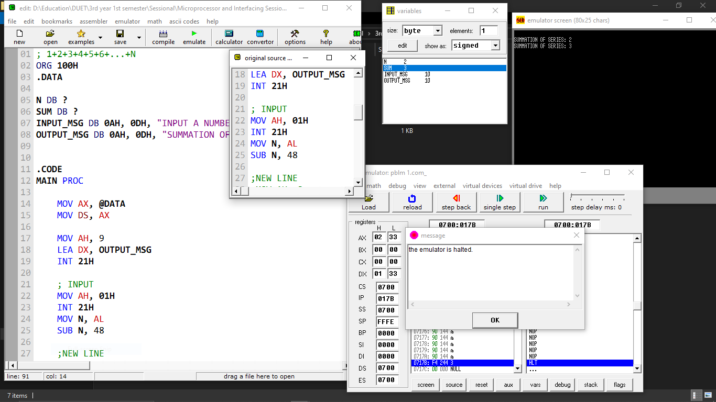

Problem 2:

12+22+32+…+N2

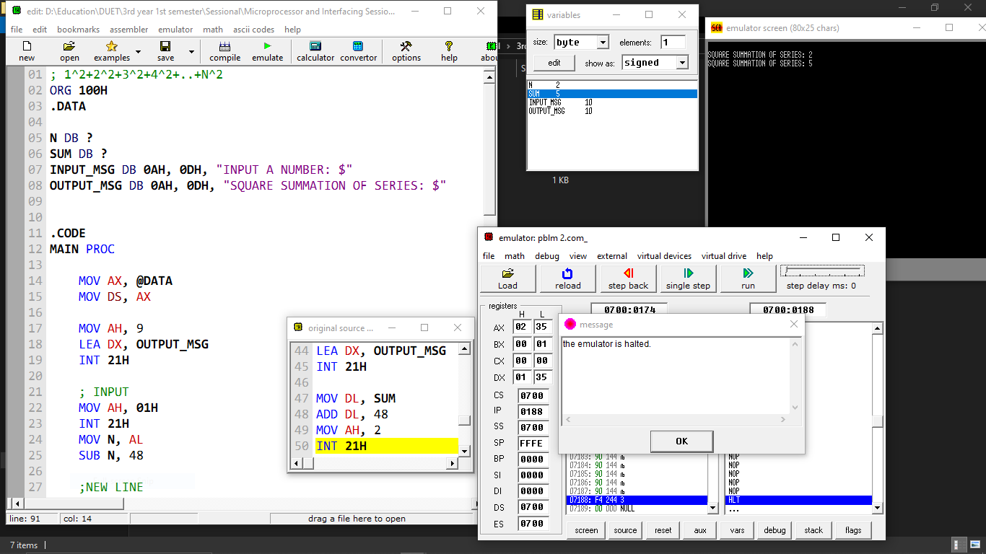

Problem 3: Corner handling

Input : Z

Output: abcde

yxwvu

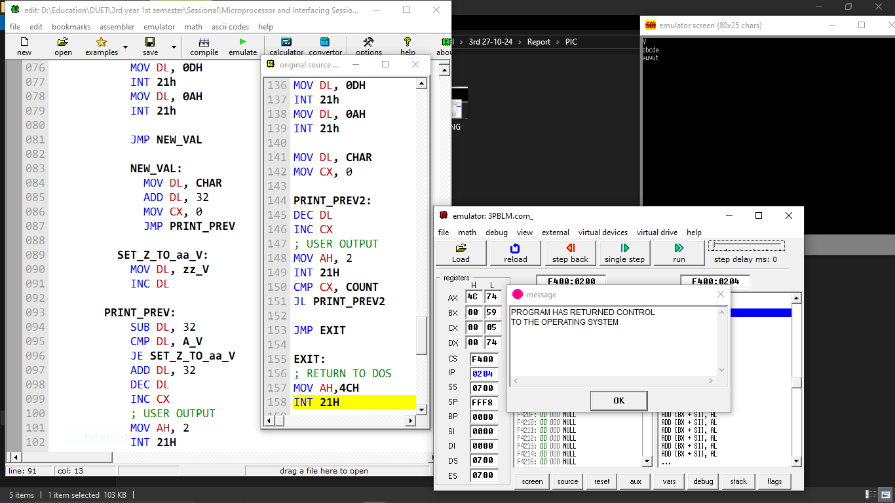

Problem 4: 